21 January 2025

Dear Parents and Carers,

Following the Christmas break and the subsequent gifts of new technology devices having been given, I felt it was a pertinent time to remind you of ways to help keep your child/children safe online.

Firstly, like all schools, we have incidents relating to learner misuse of mobile phones.  These range from bullying to the sharing of explicit images, all of which is wrong, and we wish to support parents in managing these incidents should they occur. Most young people use devices safely and without repercussion, but we know that this does not mean that others do not target them or use such platforms to cause harm.

In the main, these incidents occur outside of the school day on mobile phones provided by you as parents and carers. However, our pastoral and safeguarding teams are having to manage the repercussions of these behaviours in school, some of which have led to police reports and Children’s Services referrals. We take these matters seriously and will always involve the police where the action is of a criminal or threatening nature. Where the police choose not to act, the school will do so in line with our policies.

When you provide your child/children with mobile devices, you have a duty of responsibility as parents/carers, to ensure that you set appropriate parental controls that restrict the content available to your child, and that you frequently check your children’s devices, which includes smart TVs and games consoles, as well as mobile phones and tablets, to ensure that you know who they are in contact with and what they are doing online.

We actively discourage children from being allowed access to apps and games that are not age appropriate.

The grid below shows the national recommendations for some of the most common social media apps which we strongly urge you to adhere to, for your child’s own safety.

**SOCIAL MEDIA AGE RESTRICTIONS**

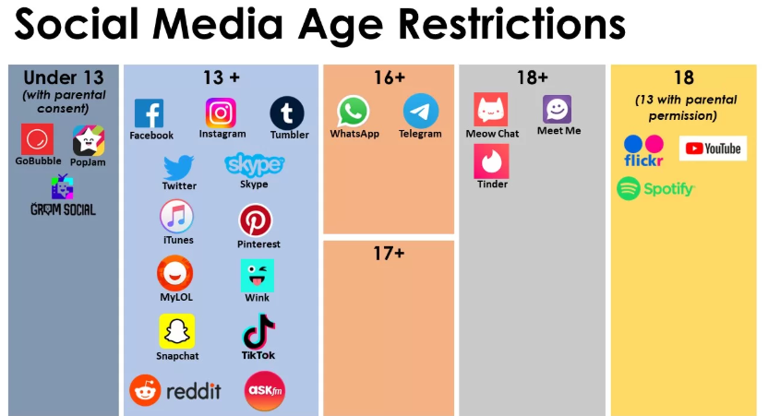

If you choose to allow your child/children to have apps below the recommended age, we suggest that you put other safeguards in place, such as frequent monitoring of your child’s devices, with particular focus on photos, contacts and social media groups, so that you are fully aware of your child’s online activity and what interactions they are having with others. Additionally, it is important to take the time to educate your child about the importance of being kind online and not sharing/posting anything that is harmful either to them or to others. The school curriculum offers opportunities to all learners to learn about the risks and safe use of social media and electronic devices, but the primary responsibility for this rests with parents.

Many of these social media apps are linked with exposure to harmful content.  Please ensure that you support your child in setting appropriate privacy settings so that they do not give away personal information that could place them at risk.

One specific concern which I would like to share with you is the existence of group wide “chats” on forums such as WhatsApp. Sadly, these are a national issue and can become hotbeds for unkind, hurtful behaviour due to a lack of maturity and understanding of the impact that such actions can have on others.  Please check your child’s device and discourage them from being part of such activity.

Some widely used apps are identified as high risk for children and young people.  You may find this information eye opening regarding the potential exposure to harmful content and the ease with which strangers can make direct contact with your child.

[**A Complete Guide to Potentially Dangerous Apps for Kids – Family Education**](https://www.familyeducation.com/entertainment-activities/online/a-complete-guide-to-potentially-dangerous-apps-all-parents-should-be-aware-of)

<https://socialguardian.org/blogs/10-most-dangerous-apps-for-kids/>

There is a wide range of information available to you as parents and carers, regarding online safety.  We would like to recommend the following as great sources of information to both you and your child/children.

* [Keeping children safe online | NSPCC](https://www.nspcc.org.uk/keeping-children-safe/online-safety/) - <https://www.nspcc.org.uk/keeping-children-safe/online-safety/>
* [Parents and Carers - UK Safer Internet Centre](https://saferinternet.org.uk/guide-and-resource/parents-and-carers) - <https://saferinternet.org.uk/guide-and-resource/parents-and-carers>
* [Keep Children Safe Online: Information, Advice, Support - Internet Matters](https://www.internetmatters.org/) - <https://www.internetmatters.org/>
* [Parents and carers | CEOP Education (](https://www.thinkuknow.co.uk/parents/)[thinkuknow.co.uk](http://thinkuknow.co.uk/)[)](https://www.thinkuknow.co.uk/parents/) - <https://www.ceopeducation.co.uk/parents/>

If you need help and support in setting up parental controls, here is a link to step-by-step guide which walks you through the instructions for a range of different devices:

[Parental Controls on Smartphones & Other Devices - Internet Matters](https://www.internetmatters.org/parental-controls/smartphones-and-other-devices/) - <https://www.internetmatters.org/parental-controls/smartphones-and-other-devices/>

It is important that children are aware of the law in relation to explicit image sharing.  Any nude or semi-nude images of children under the age of eighteen is considered as child pornography. It is against the law to generate, publish or share these images with others.  Please ensure that your child is aware of this. If they receive an image, this is not their fault.  However, they do need to ensure that this is reported to an adult, either in school or at home. If school becomes aware of explicit image sharing, we are required to report this to the police which can result in phones being removed and retained for the course of the investigation. This process can take several weeks.

We cannot stress enough the importance of talking to your child regularly about their online habits, and the need to frequently check devices. Your child may not like this but as their parent/carer and the person who provides the device and pays the bills, you have the right to make these checks to ensure that your child is safe and that their behaviour online is responsible both in regard to their own safety and in their conduct towards others.

Lastly, please encourage your child to have some time away from their devices every day. Whilst there are some benefits to being online, the negative impact of the excessive use of electronic devices on emotional well-being, sleep patterns and mood is considerable.  We advise an agreed shut off time in the evening and the removal of all devices over night as good parenting practice. This guide may help you to have conversations with your young person on how to balance their screen time more effectively: <https://www.internetmatters.org/wp-content/uploads/2021/02/Internet-matters-ScreenTimeGuide-KeyStage4-V2.pdf>

If you have any questions or concerns relating to online safety, please contact your child/children’s Pastoral Co-ordinator in the first instance.

Yours sincerely,



Mrs D Millington

**Deputy Headteacher & Designated Safeguarding Lead**